RS Encoding Algorithm

1. Reed-Solomon Codes Basics

Maximum Distance Separable (MDS) Codes:



The Singleton bound is reached.

Code Length:

For , 

1. Encoding
2. evaluation mapping:

Message polynomial:



Codeword polynomial:



1. sytematic encoding

Suppose:



Then:



Thus,  is the message polynomial, and  is the parity polynomial which is the remainder of dividing  by the generator polynomial .

1. Encoder Architectures

The message symbols are shifted out first while the the parity symbols are generated (by a divider based on LFSR). After k cycles (control by a multiplexor), the parity symbols are ready, then they are shifted out.

The calculation defined for finite filed can be related to some calculation tables.

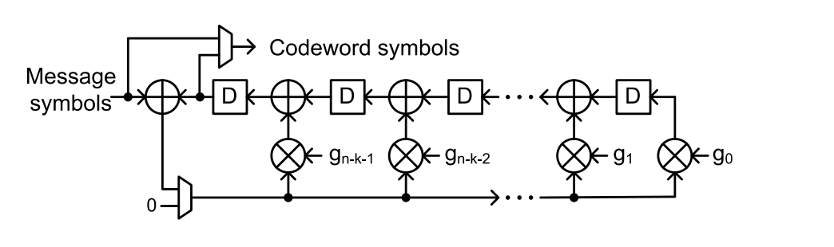

The theory of LFSR can be seen as below:

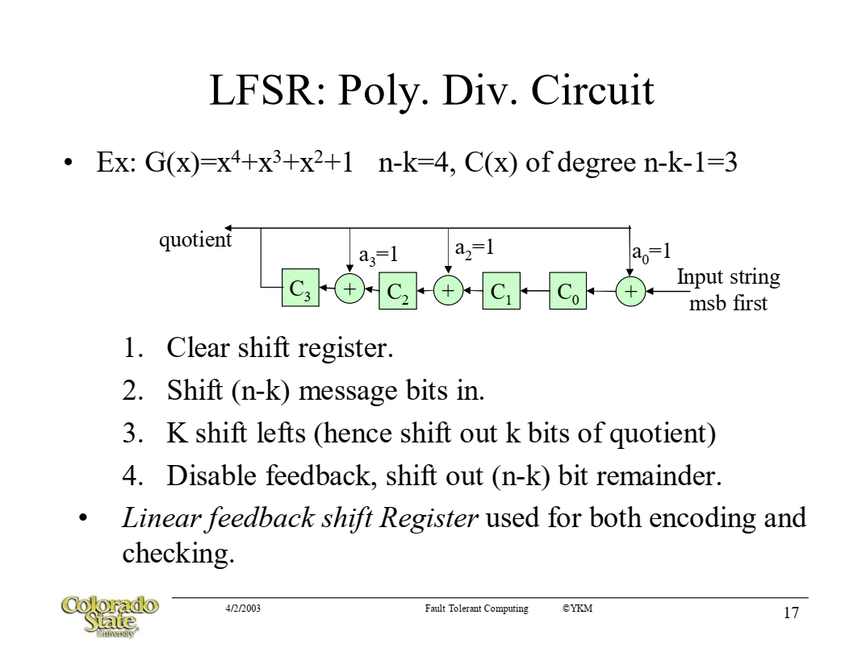

1. Complexity Analysis

Time:

n cycles

Space:

1 multiplexor, n-k registers, n-k multiplier, n-k adder.

Nothing has to be stored.